Capstone 33.4 Step 9: Pick Your Deployment Method

Streamlit for Deployment of Financial Sentiment Analysis Machine Learning Project

In our financial sentiment analysis project, we leverage GitHub to store our code, Hugging Face to store the trained models to utilize the models for inference, and Streamlit as our frontend and deployment platform. Streamlit offers a straightforward yet powerful way to build and share data-driven web applications, making it an ideal choice for deploying machine learning models.

Why Streamlit?

Streamlit is designed for simplicity and ease of use, allowing developers to create interactive web applications with minimal effort. Its Python-centric approach ensures seamless integration with our machine learning models and data processing pipelines.

Key Features of Streamlit

- Interactive Widgets: Streamlit provides a variety of interactive widgets such as sliders, text inputs, and buttons, enabling users to interact with the application and explore different scenarios.
- Real-Time Updates: Any changes to the input or parameters trigger real-time updates, ensuring that users receive instant feedback from the model.
- Seamless Integration: Streamlit works well with popular data science libraries like Pandas, NumPy, and Scikit-Learn, facilitating the integration of our sentiment analysis model.
- Visualization Capabilities: With built-in support for plotting libraries like Matplotlib and Plotly, Streamlit allows us to visualize the sentiment analysis results effectively.
- Easy Deployment: Streamlit applications can be easily deployed on various platforms, including Streamlit Cloud, Heroku, and AWS, making it convenient to share the application with stakeholders.

Potential Implementation

- Daily Financial Headlines with respective predicted sentiments for the day: When the webpage is access the models will each predict the sentiments from the top financial headlines of the day.
- User Input: For each model there will be a user input section where users can submit financial news headlines or other text input. This input is captured using StreamLit's st.text_input widget.
- Multiple Model Prediction: Upon submission, the input headline is processed by our pre-trained sentiment analysis models. These models predicts the sentiment (positive, negative, or neutral) of the headline. We can see the various sentiment predictions for news headlines
Example Code Snippet

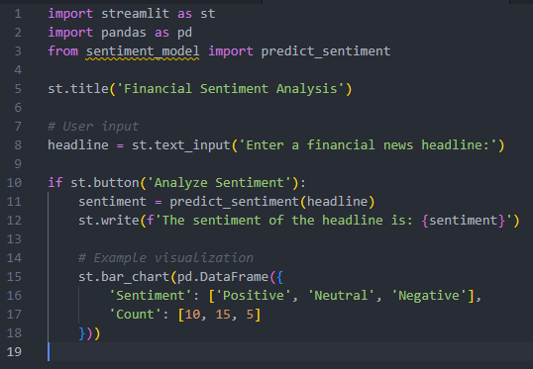

This example showcases the simplicity and effectiveness of using Streamlit for deploying a machine learning model for financial sentiment analysis. By leveraging StreamLit's features, we provide an interactive and insightful application that can aid in making informed financial decisions based on news sentiment.

Factors to Consider

- Costs: If I do use or update my project to use AWS services then I may incur some financial costs, however I am currently on the free tier which should lessen the financial damage.
- Speed of Deployment: This is a small application and should only take a few minutes to deploy.
- Performance of Model: I plan to use a static trained models to predict the financial sentiments, so performance should be relatively quick
- Monitoring: If I do use or update my project to use AWS services, I will check out AWS CloudWatch
- Logging: CloudWatch Logs, implement python debugging logs

Potential Enhancements

- Results Display: The predicted sentiment is displayed on the web interface. Additionally, we provide visualizations such as bar charts to show the distribution of sentiments over a period or across different sectors.
- Interactive Features: Users can explore various features, such as filtering results by date or sector, viewing historical sentiment trends, and comparing sentiment against stock performance.
- Feedback Mechanism: Users can provide feedback on the sentiment classifications, which helps us collect valuable data to refine and improve our model.

